Occu-Med, LTD
Provider Service Agreement

Provider: Clinic / Provider Name
Address 1
Address 2

Effective Dates: MONTH DD, YYYY --

Billing Terms: NET 30

Fees:

Treadmill Stress Test with Interpretation (CPT Code: 93015) | $
Stress Echocardiography with Interpretation (CPT Code: 93351) | $
Resting EKG with Interpretation (CPT Code: 93000) | $
Fitness-for-Duty Cardiology IME (CPT Code: 99456) | $

Attests:

Sherri Conley, Controller Occu-Med Name (Print) Title Clinic / Provider Name (Print) Title

Sherri Conley (Signature) Date. Clinic / Provider Name (Signature*) Date

* I understand and acknowledge my responsibility to adhere to relevant and applicable portions of the HIPAA Privacy Rule.
  - Provider Contact Information

Clinic Name:

Address:

City, State Zip:

Telephone: Fax:

Hours of Operation (write CLOSED if closed):

Monday: Tuesday: Wednesday: Thursday: Friday: Saturday: Sunday:

To ensure communication remains efficient and occurs with the most appropriate staff member, please complete the following:

Schedule Preferred method (circle): phone, fax or email
Name, Title:

Telephone: Email:

Exam Result
Name, Title:

Telephone: Email:

Billing
Name, Title:

Telephone: Email:

Manager/Supervisor
Name, Title:

Telephone: Email:

Corporate
Name, Title:

Telephone: Email:

Treadmill Stress Testing Guidelines

Treadmills conducted for Occu-Med have the purpose of assessing functional capacity pursuant to specific employment criteria.
Accordingly, please adhere to the following:

- 12 METs minimum (as permitted by exercise tolerance); and,
- 85% MPHR is the minimum HR for a valid test.

Notes: Both 12 METs and 85% MPHR are required (if physically achievable by the individual) for a test to be valid.

Please do not terminate a test early solely because 12 METs is achieved if the MPHR is less than 85% or, conversely, if MPHR is achieved but 12 METs is not.

The use of treadmill handrails during testing should be prohibited unless utilized briefly for repositioning.

There are obvious circumstances where one or both criteria may not be met (e.g., deconditioning; pre-existing limiting injury; treadmill EKG abnormality, etc.) which result in premature termination. Please be sure to note any relevant data on the provided Occu-Med Treadmill Stress Test report page (enclosed).

If there are any concerns at the time of testing, please contact Occu-Med at 559.435.2800 x104.

Thank you,
Occu-Med

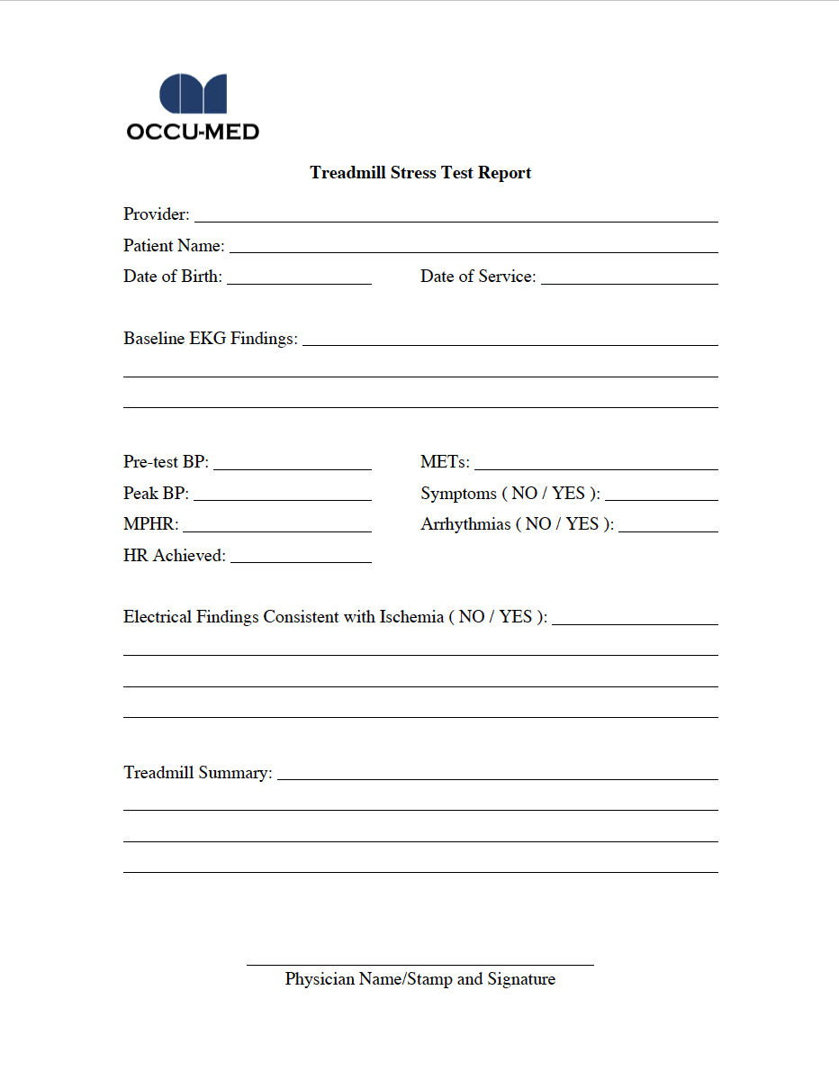

  - Occu-Med Contact Information

Company Name: Occu-Med, LTD

Address: 2121 W Bullard Ave

City, State Zip: Fresno, CA 93711

Telephone: (559) 435-2800 Fax: (800) 262-2863

Hours of Operation:

Monday: 7:00am to 5:00pm PST
Tuesday: 7:00am to 5:00pm PST
Wednesday: 7:00am to 5:00pm PST
Thursday: 7:00am to 5:00pm PST
Friday: 7:00am to 5:00pm PST
Saturday: CLOSED
Sunday: CLOSED

The following are pertinent points of contact:

  - Network Management
Name | Title | Telephone | Email: Matt Caskey | Director | x104 | mcaskey@occu-med.com

Provider Relations

Name | Title | Telephone | Email: Liz Zecchini | Manager | x153 | elizabeth.zecchini@occu-med.com

EXAMQA

Name | Title | Telephone | Email: Dana Tamayo | Director | x159 | dtamayo@occu-med.com

  - Communications
Name | Title | Telephone | Email: x172 | communicationsmanager@occu-med.com

  - Scheduling
Name | Title | Telephone | Email: Liz Mathies | Director | x151 | elizabeth.mathies@occu-med.com

  - Operations
Name | Title | Telephone | Email: Chase Coyle | Director | x102 | ccoyle@occu-med.com
  - Finance
Name | Title | Telephone | Email: Alyson Tillery | Director | x116 | atillery@occu-med.com

